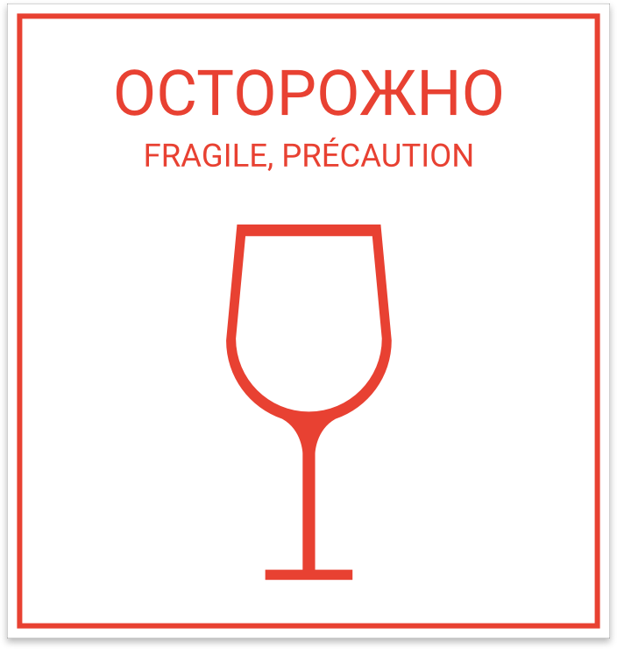

Kantsara V. D.
st. Zelenaya,33
s. Kharkiv, 61009
Ukraine
tel. +380 99 440 3325

Kantsara V. V.
16109 Wind Drive, Edmond, OK, 73013, USA
tel. +1 405 209 91 70

–––––––––––––––––––––––––––––––––––––––––––––-

Kantsara V. D.
st. Zelenaya,33
s. Kharkiv, 61009
Ukraine
tel. +380 99 440 3325

Kantsara V. V.
16109 Wind Drive, Edmond, OK, 73013, USA
tel. +1 405 209 91 70

