Mаryichuk Natalia  Ukraine, Lviv Refugee Ukraine in Spain\ready to move |  | 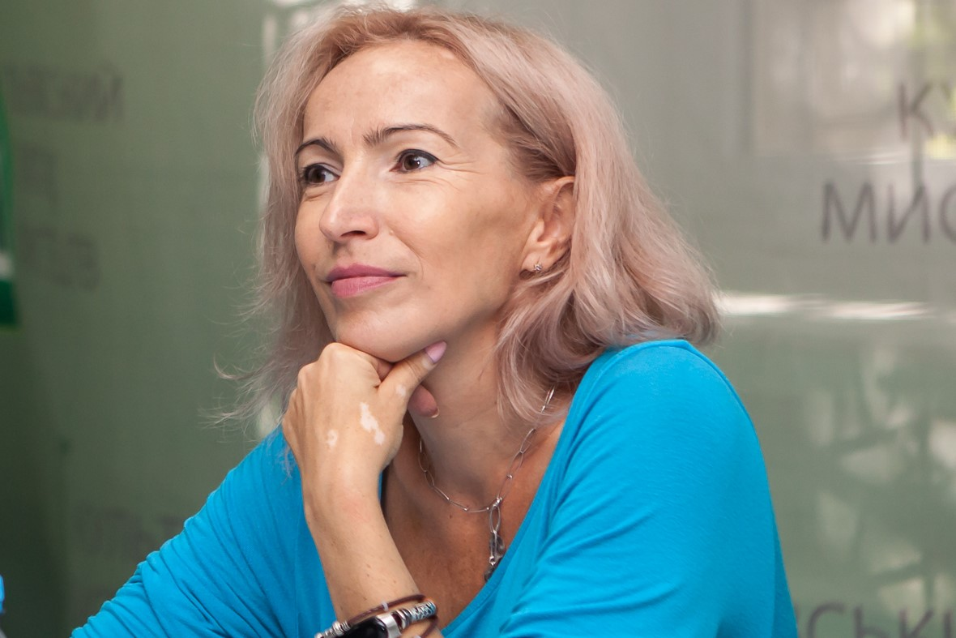
Date of birthday: | 12.01.1974
Tel: | 38096 4268047 
E-mail: | natamaryichuk@gmail.com
Marital status: | married, three children.
FB: | facebook.com/nataliya.mariychuk

Professional activities
08.2018– until today Beauty Salon ‘Nosach’, Massage therapist, Lviv, Ukraine
Experience Therapeutic massage Serving up to 75 clients per month. Anti-cellulitic program Vacuum roller massage Face massage Back massage Kinesiology taping
03. 2015 – until today -- writing grant programs and business plans with investments up to 500000 UAH
--interesting and development of the latest technologies in agriculture, give advice of growing green on hydroponics, development of technological process of cultivation, consulting to start a business and start urban hydroponics farms
Achievements: with our team, we open 4 hydroponics crop farms in Ukraine. https://hydroponics.net.ua/uk/golovna/
https://www.facebook.com/hidroponikadlyavsih/
2013 – march 2015 maternity leave
2011 – december 2012 business owner
--consultant in advising organization business and finance
--participation in open tendering proceeding
dec 1996 - dec 2010 Director of the private enterprise PPF "Promsnab" (up to 40 employees)
- organization of the shopping center and supermarket;
- budgetary planning of the enterprise;
- control of bookkeeping, cash flow, storage facilities, inventory;
-management of the team;
Achievements: building a shopping center from scratch, attracting international companies to cooperate.
Education
1991 – 1996yy Higher School of Business – Institute Economics and Management Alchevsk, Lugansk Region Ukraine Faculty of Management, Team Leader
Additional education
March 2015 course opening of own business from the International Organization Of Migration NGO "Women's Perspectives"
June –august 2015 MBS course "make Business successful" Club of Business People Lviv, Public School Of Business
2015 – 2016yy Training course on development of entrepreneurship and financial management of the BF "Center for supporting initiatives" Cooperative Academy with the support of the British Embassy in Ukraine
March 2017 Seminar with the leadership for the project " Public Bridges " with the support of the EU
Jule 2017 «School of leaders of Gromad» Ukrainian school of political studios in Kiev

November 2017 – February 2018 «School of Democracy» Lviv Eastern European Center

May 2018 –December 2019 School of massage technologies "Ostnova"

August 2021 – September 2021 Project Management Course (Kyiv) Laba International Business School
Additional information:
Language skills: Ukrainian (native), Russian (free), English (pre-intermediate, needs improvement)
Computer Skills: free, MS, 1C Accountancy. Excel, Word…
Driver's license: Certificate of category "B", experience of 10 years
Personal qualities: organizational skills, commitment to learning and the latest technology

