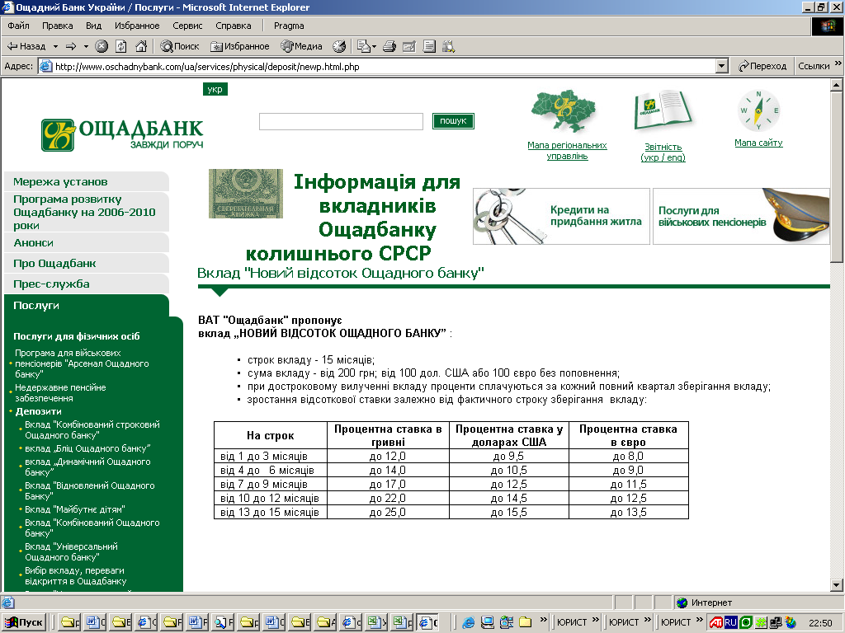

http://www.oschadnybank.com/ua/services/physical/deposit/newp.html.php

